ASSIGNMENT 45

Name : Akanksha Joshi

Roll No : B038

Batch : 3

Div : BTech CS B

-------------------------------------------------------------------------------------------------------------------------------

Source Code

**1.**

import re

matched = re.search("Hello Alex","Hello Alex,your Customer id is aj21",re.I)

print(matched.group())

**2.**

import re

customer_details = "Hello Alex, your customer ID is c23"

print("Given String: ", customer_details)

m = re.search(r'[a-zA-z]\d+$', customer_details)

if m is not None:

print("Pattern Found: ", m.group())

**3.**

import re

customer_details = "Hello Alex, your customer ID is c23"

customer_details2 = customer_details.replace("c", "")

print("Original String: ", customer_details)

print("After Replacing: ", customer_details2)

**4.**

import re

customer_details = "Hello Alex, your customer id is c23"

word = "id"

customer_details3 = customer_details.replace("id", word.upper())

print("Original String: ", customer_details)

print("After Replacing: ", customer_details3)

Output

1.



2.



3.

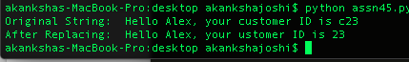

4.

